7 Important Tips for Improving Your Web Design
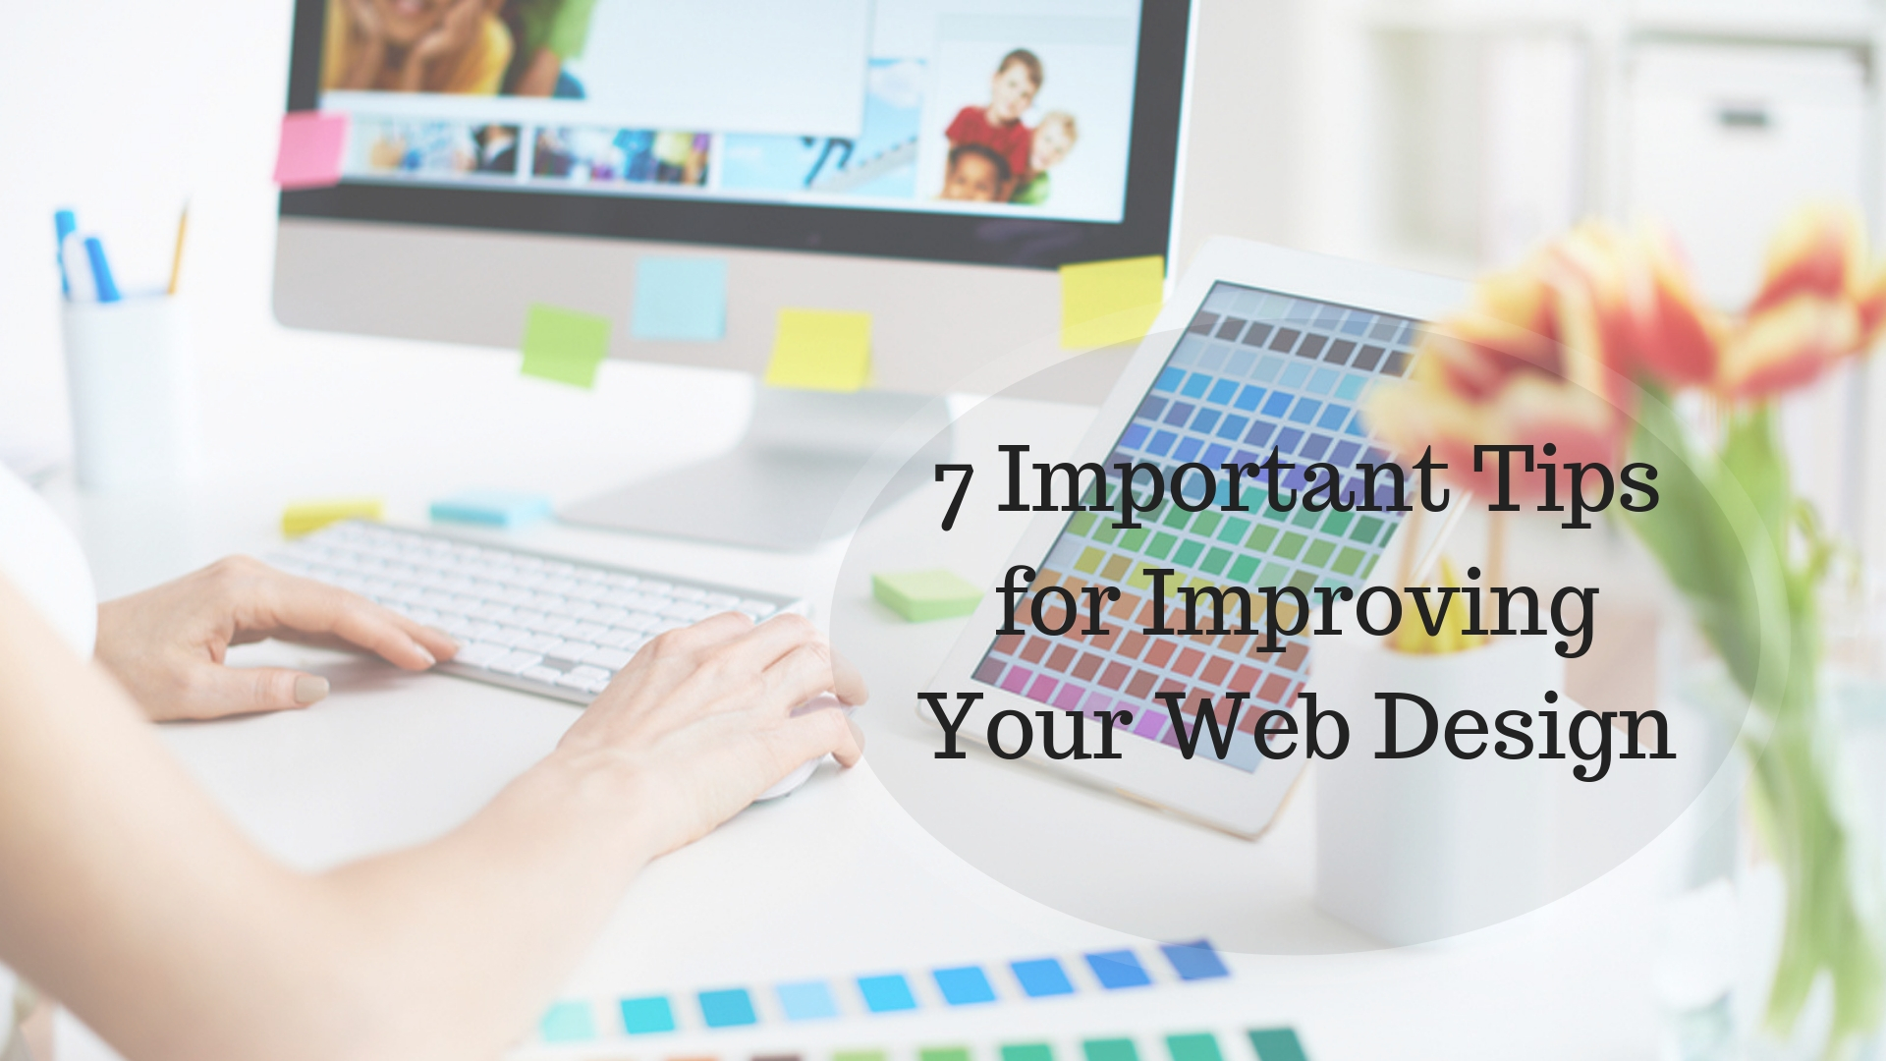

How Much Does a Website Cost to make available to its visitors what they want? Is it capable of inclining them to take a full tour of the website? Can it help them advance through all the pages? Is the way the website is designed optimizing to the level of user-friendly behavior?
To know answers of all of these queries one should take a note of the ways in which users surf the website by taking a keen look at the web design methods. Whether the viewers can determine at once the nature of the content, or easily navigate to the blog if there is such a requirement or are they able to grasp how much does a website cost and apprehend the layout of its pricing is important for a service provider. If one is finding it hard to give a positive answer to, all these questions mentioned above, then there is a need to feel concerned about the web designs and their optimization quality. One should give priority to the problems faced by users.
- Need to practice designs without any fear to chalk out a plan
As the proverb says that practice makes a man perfect, one should indulge in practicing the kind of designs to help improve a website. This can be done by creating a localhost in Windows or in Mac. One should include catchy themes to make the website look elegant. This is the sandbox which one should use to try new design concepts without fear. Then, one should think of mapping the journey of a viewer. Pointing out what type of pages or the content they would look into is a concern for the designer. Every step should be set in the right order.
- Get worldly inspiration to avoid using ambiguous terms and images
Employing content that is too long or using complicated images and animations can bore a viewer and devalue the message that one is trying to convey. The very first impression on the users should be such that they get a glimpse of what the main points are within seconds after landing there. There should be subsections and no use of jargons. Designs should be this viewed like a critic to figure out useful techniques for improvisation.
- Including social share, follow buttons to examine design feedback
Web designing in such a way that getting and giving feedback on work, respectively, is important. The former helps one to find areas to develop and the latter to improve one's skill. This can be achieved by starting blogs or joining forums through various social pages. A website without any such social buttons may slacken in the sales race. One could miss out on social media traffic and its broadcast can come to a rest. These social icons help one to share the content on the desired social channel. This enables to keep a track of advancement of design incorporated.
- Introducing call-to-action strategy
These buttons inform the users about the next step in a webpage. These enable viewers to solve their issues and provide them with materials to educate themselves. These must relieve the stress points of the visitors so that they can rely on the website. Some examples of these are, ‘click here for more information’, ‘download the GamePlan’, etc.
- Accurate navigation facility
Navigation is the tool used as the essential map to display the main places users can visit when designing a website. They should be able to find exactly what they are searching. Navigation should be hierarchical and responsive to he design.
- User-friendly homepage design
The viewer would be able to freely scroll down homepage so that they are devoid of any confusion. A clean homepage with legible writing is the key to attract an audience. It should definitely consist of 3 to 5 sections describing the whole idea of the content. This website design packages truth is evident through sections like overview, testimonials, success stories, about us, and many more.
- Focusing on trends
One should stay updated regarding everything that shares the website design packages truth. This provides for improving oneself at designing a website as this is quite a trend driven. One should never blindly adopt a design but should comprehend it by paying attention to it.
One can also implement these following points in order to serve better the website design packages truth to the viewer-
- Optimizing the newly made site for the user-friendly mobile system. It is because it has become a necessity nowadays to serve the best user-friendly site to fit into the wants of the users. One should attempt to create a hassle-free experience of the website for the convenience of the users.

- By developing a substantial presence on the online market through the very popular Search Engine Optimization, commonly called SEO, technique. There is always a requirement to get found in the best way possible to increase the presence. It must take into consideration the search terms and names the users and viewers look for. Thus it should include videos, blogs, and the like kind of content as is relevant to the needs of the visitors. However, do not infuse the article with too many endless content possibilities. So one should identify the proper keywords first to attract that audience who are going to revert back to the service provider.

- There is also a need to evaluate the way the pages of the website are researched by the users. That is to say, whether they are scrolling the whole or just looking at only a few lines do matter a lot in acknowledging the website content and their interest upon it. This also gives a major feedback on whether the website is showing expected performance or not. There should be up to the mark updates and the much-needed design changes, like button colors, headers, footers, etc. to keep the viewers glued to the website. However, if one has no idea on what to change, then, in that case, one can set up the heat maps and multi-variant tests to see what the users are doing and how they are interacting with the website.

- One user can find it difficult to look at an unknown error namely, error 404, occurring when trying to see a content. This should be taken care of and those links should be fixed as fast as possible.

- By providing unique offers to the viewers one can hold them. Converting the visitors by providing them with absolutely special offers, deals, videos, demos, and items that they would find attractive is a strategy that one can utilize to keep on increasing the marketing funnel of the website. Maybe it could the benefit in the sense that one can create tools, or apps or templates to guide visitors through. One should always keep in mind to present the comfort of the users and the difficulty for the competitors.
- Content should be updated to match the personality and status of the website. The potential customers always search for an opportunity to meet an eye to eye with the developers. So instead of using words like ‘our’, one can try to use ‘your’ for the viewers so that they feel like one is helping understanding their problem and helping them to solve it. This usage subconsciously affects the manner in which customers view it.

Last but not least, it is needless to emphasize the fact that there is no such shortcut to successfully achieve a better website design packages truth. It is important to be consistent and develop a critical eye to try something new every day. One should always try to become an active learner in order to keep up with the world. One can check blogs and read eBooks to get a hold of what newness is there in the designs that can appeal to a viewer.

About The Author
Kavya gajjar is a Marketing Manager at AIS Technolabs which is Web design and Development Company, helping global businesses to grow by Web Design Agency. I would love to share thoughts on Social Media Marketing Services and Game Design Development etc.

